**Task 1 – Verify VM resources in VMware:**

1. Open VMware Workstation and locate the Ubuntu Server VM you used in Lab 1.
2. Inspect VM settings and note the following (no commands required for GUI): VM name, RAM, CPU, disk, and network adapter type.
3. Take a screenshot of the VM settings window showing RAM, CPU, disk and networking.

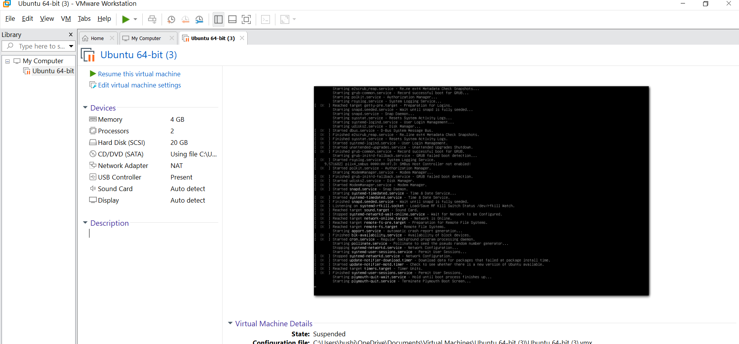

## Task 2 – Start VM and log in (use your preferred host terminal method only)

